**Aditya P Tahiliani Batch :- C**

**D15A_59**

**Experiment no. :- 06**

**Aim: To Connect Firebase Database With Flutter UI**

# Theory:

Firebase is a great backend solution for anyone that wants to use authentication, databases, cloud functions, ads, and countless other features within an app.

# Prerequisites

To complete this tutorial, you will need:

* A Google account to use Firebase.
* Developing for iOS will require XCode.
* To download and install Flutter.
* To download and install Android Studio and Visual Studio Code.
* It is recommended to install plugins for your code editor:
  + Flutter and Dart plugins installed for Android Studio.
  + Flutter extension installed for Visual Studio Code

This tutorial was verified with Flutter v2.0.6, Android SDK v31.0.2, and Android Studio v4.1.

# Creating a New Flutter Project

This tutorial will require the creation of an example Flutter app.

Once you have your environment set up for Flutter, you can run the following to create a new application:

flutter create flutterfirebaseexample

Using flutter create will produce a demo application that will display the number of times a button is clicked.

Now that we’ve got a Flutter project up and running, we can add Firebase.

# Creating a New Firebase Project

First, log in with your Google account to manage your Firebase projects. From within the Firebase dashboard, select the Create new project button and give it a name:

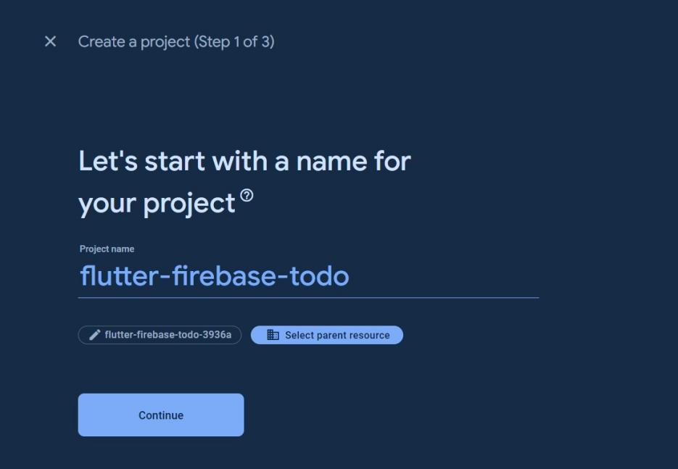

**flutter-firebase-paytm**

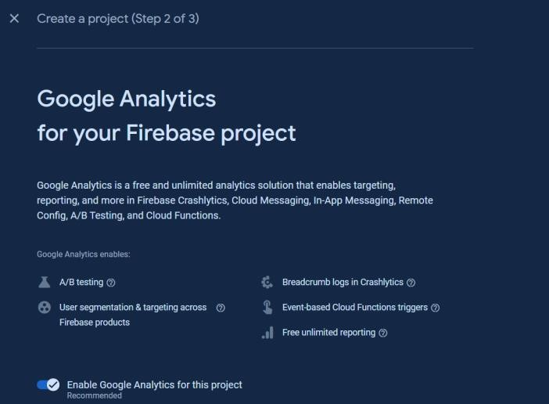

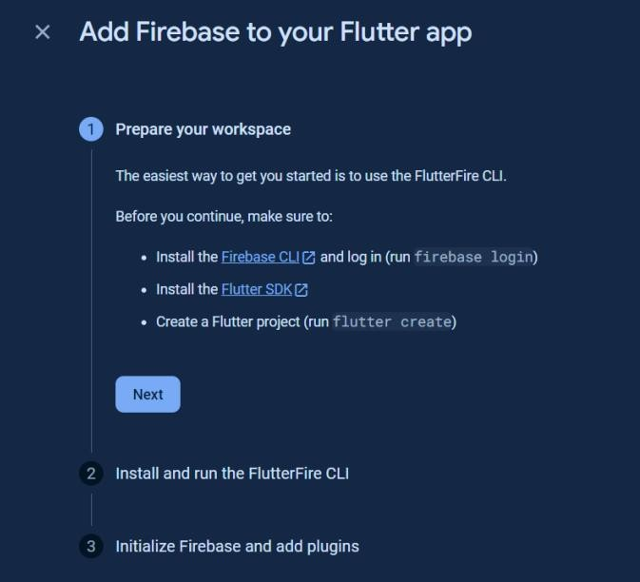

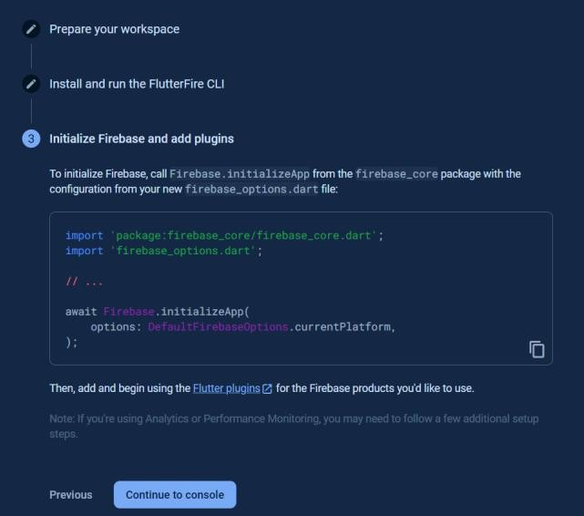

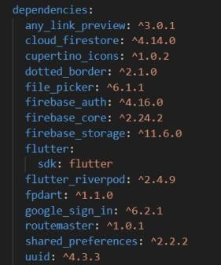



**paytm**

**Conclusion :-** Thus, we successfully Connected Firebase Database With Flutter User Interface.